**User Manual of Witness List:**

**Witness List Form**

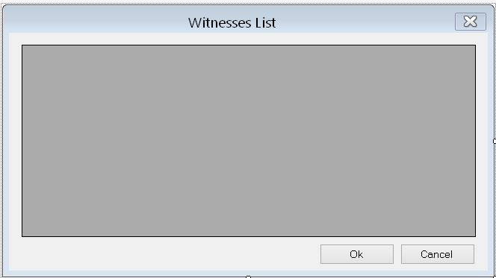

This form displays the list of the Witnesses.